

Northeastern University

Data Management and Database Design

INFO6210

Spring 2019

Hyperparameter Database Team 11

Project Report

By Darshan Durve & Shriram Karthikeyan

# Abstract

The goal of this hyperparameter project is to create a database consisting of hyperparameters that were extracted by running various machine learning models (classification/regression) on multiple datasets. Using the database of hyperparameters that is generated we will suggest hyperparameters for the dataset that the user would like to run ML models on; this aspect of the project is not currently within our scope therefore we will limit ourselves to building a database of hyperparameters for one dataset.

# The Dataset We have got the CalCOFI dataset from Kaggle.com. The data set represents the longest (1949-present) and most complete (more than 50,000 sampling stations) time series of oceanographic and larval fish data in the world. It includes abundance data on the larvae of over 250 species of fish; larval length frequency data and egg abundance data on key commercial species; and oceanographic and plankton data.

# ER DIAGRAM

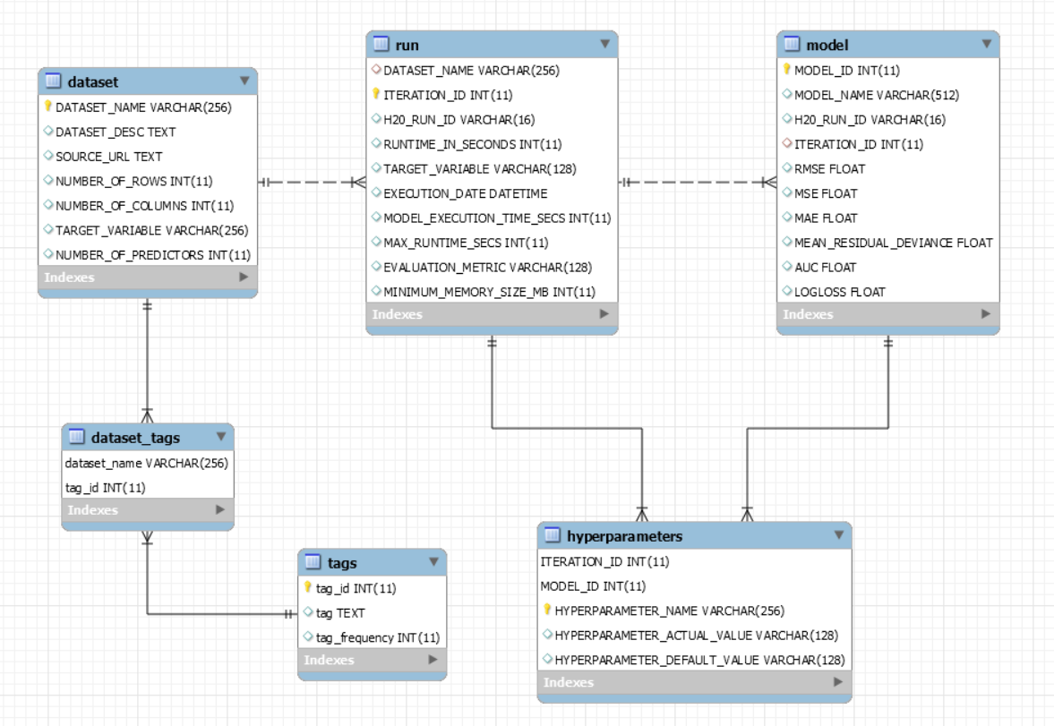

Above E-R diagram explains the relationship between the models for each run with their hyperparameters. Each run has different models generated by H2O and each model has different hyperparameters associated to it. We have also stored tags to associate the dataset with keywords.

# Use Cases

1. Retrieve the rmse value for the models of the lowest runtime.

* select m.model_name, m.rmse from model m join run r on m.iteration_id=r.iteration_id

where r.max_runtime_secs=(select min(max_runtime_secs) from run);

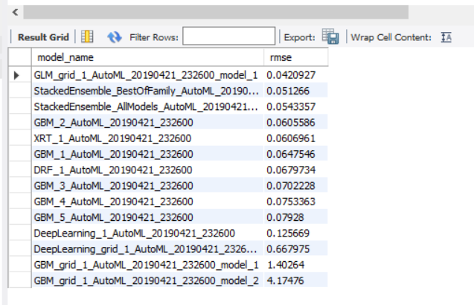

1. Retrieve the runid from the meta-data for the lowest runtime.

- Select h20_run_id, max_runtime_secs as runtime_in_secs from run where max_runtime_secs=(select min(max_runtime_secs) from run);

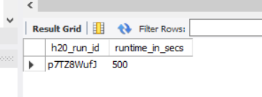

1. Retrieve the ntrees from the Random Forest algorithm.

- select m.model_name, h.hyperparameter_name, h.hyperparameter_actual_value

from model m join hyperparameters h on m.model_id=h.model_id

where m.model_name like 'drf%' and h.hyperparameter_name = 'ntrees' order by h.hyperparameter_actual_value desc;

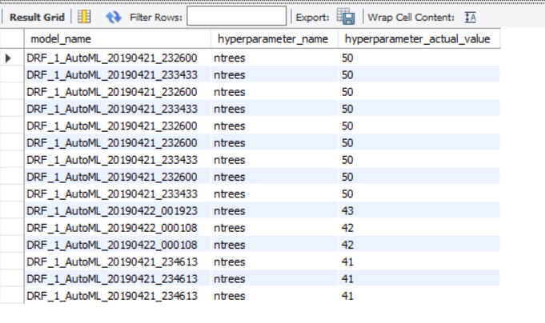

1. The default max_depth of the models

- select m.model_name, h.hyperparameter_default_value from hyperparameters h join model m on h.model_id=m.model_id

where h.hyperparameter_name = 'max_depth';

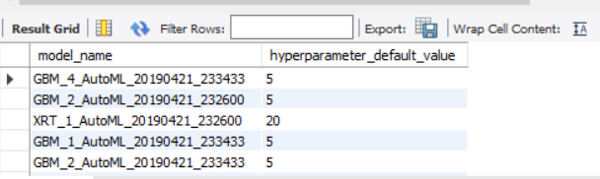

1. The mean residual deviance for the top 5 models of the lowest runtime.

#Based on rmse

select model_name, mean_residual_deviance as mrd, rmse from model m join run r on m.iteration_id=r.iteration_id

where r.max_runtime_secs=(select min(max_runtime_secs) from run) order by rmse limit 5;

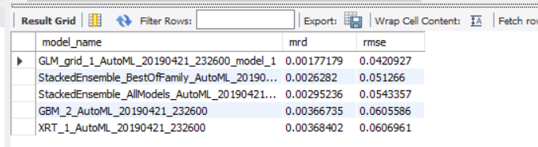

1. Sum of rmse values of any least or highest runtime.

#For highest

select sum(rmse) from model m join run r on m.iteration_id=r.iteration_id

where r.max_runtime_secs in (select max(max_runtime_secs) from run);

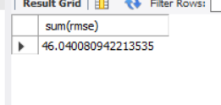

#For lowest

select sum(rmse) from model m join run r on m.iteration_id=r.iteration_id

where r.max_runtime_secs in (select min(max_runtime_secs) from run);

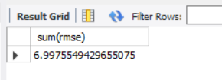

1. The number of models of the same algorithm for a particular runtime(1100).

select model_name, count(*) from model m join run r on m.iteration_id=r.iteration_id

where r.max_runtime_secs = '1100' and model_name like 'GBM%';

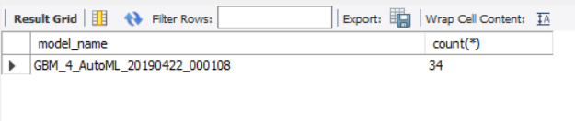

1. The difference between the highest and lowest mae values of the models for a runtime.

select r.max_runtime_secs, max(m.mae)-min(m.mae) as range_of_mae

from run r join model m on m.iteration_id=r.iteration_id group by r.max_runtime_secs

order by max_runtime_secs;

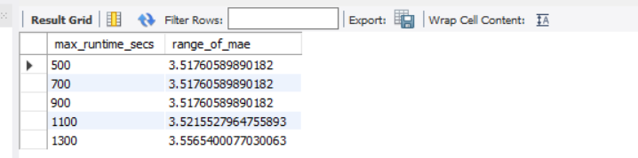

# Functions

1. Function to suggest a dataset based on the given tag –

CREATE DEFINER=`root`@`localhost` FUNCTION `fetch_dataset`(tag_name varchar(128)) RETURNS varchar(128) CHARSET utf8mb4

BEGIN

declare dataset varchar(128);

select distinct d.dataset_name into dataset from tags t join dataset_tags d on t.tag_id=d.tag_id where tag like concat('%',tag_name,'%');

RETURN dataset;

END

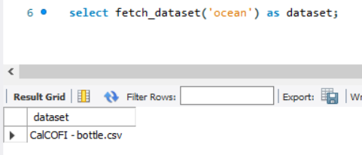

1. Function to suggest best value of specified hyperparameter of specified model at specified runtime

CREATE DEFINER=`root`@`localhost` FUNCTION `best_hyperparameter`(runtime varchar(128), model varchar(128), hyper varchar(128)) RETURNS varchar(128) CHARSET utf8mb4

BEGIN

declare best_value varchar(128);

select distinct HYPERPARAMETER_ACTUAL_VALUE into best_value from model m join run r on m.iteration_id=r.iteration_id

join hyperparameters h on m.model_id=h.model_id

where r.max_runtime_secs = runtime and

m.model_name like concat('%',model,'%')

and h.hyperparameter_name like concat('%',hyper,'%')

and m.rmse = (select min(m.rmse) from model m join run r on m.iteration_id=r.iteration_id

where r.max_runtime_secs = runtime and m.model_name like concat('%',model,'%'));

RETURN best_value;

END

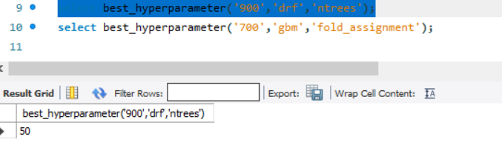

# Citations

https://stackoverflow.com/questions/19587118/iterating-through-directories-with-python

https://stackoverflow.com/questions/7099290/how-to-ignore-hidden-files-using-os-listdir

https://stackoverflow.com/questions/845058/how-to-get-line-count-cheaply-in-python

https://stackoverflow.com/questions/48996822/python-drop-rows-from-a-pandas-dataframe-that-contain-numbers

https://stackoverflow.com/questions/11346283/renaming-columns-in-pandashttps://www.nltk.org/book/ch05.html

https://www.nltk.org/book/ch05.html

https://stackoverflow.com/questions/2661778/tag-generation-from-a-text-content

https://stackoverflow.com/questions/14753321/add-auto-increment-id-to-existing-table

https://stackoverflow.com/questions/8384737/extract-file-name-from-path-no-matter-what-the-os-path-format

https://www.interviewqs.com/ddi_code_snippets/add_new_col_df_default_value